7COM1079-0901-2025 - Team Research and Development Project
Final report title: Helium (HNT) Cryptocurrency Correlation Analysis
Group ID: [B 157]
Dataset number: ds299
Prepared by: [Name: Muhammad Hasham Tahir, Student ID:24135458], [Name: Mohammed Altamash Ahmed 24135265], [Name: J.Mills-Marfo, Student ID: 24135550]
University of Hertfordshire Hatfield, 2025

Table of Contents
- Introduction
  - Problem statement and research motivation
  - The data set
  - Research question
  - Null hypothesis and alternative hypothesis (H0/H1)
- Background research
  - Research papers (at least 3 relevant to your topic / DS)
  - Why RQ is of interest (research gap and future directions according to the literature)
- Visualisation
  - Appropriate graphs for the RQ output of an R script
  - Additional information relating to understanding the data (optional)
  - Useful information for the data understanding
- Analysis
  - Statistical test used to test the hypotheses and output
  - The null hypothesis is rejected/not rejected based on the p-value
- Evaluation – group’s experience at 7COM1079
  - What went well
  - Points for improvement
  - Group’s time management
  - Project’s overall judgement
  - Comment on GitHub log output
- Conclusions
  - Results explained
  - Interpretation of the results
  - Reasons and/or implications for future work, limitations
- Reference list
- Appendices
  - R code used for analysis and visualisation
  - GitHub log output

1. Introduction

Problem statement and research motivation :
Helium is said to be the interesting example crypto and real world overlap with each other. The pump and dump in helium can be of two reasons either people believe that project is for long term, or just people making risky for short term trading? This research matter because some of the cryptocurrencies are connecting with real world like IOT and helium is one of them and this way it is quite different from regular digital money like bitcoin, etherium etc. apart from crypto we had also studied bitcoin but the ambiguity in prices of bitcoin is too much to analyze how it will behave, while understanding pricing behavior is very important for investors, researchers, and tech fans. the reason for this is for investors if they can't analyze the price how will they bet, same for the researchers if they dont know how this behave they how can they adopt this as a real money.

The data set :
The dataset (ds299, Helium.csv) contains 7 rows and 717 columns, the period of which spans June 8, 2020, to May 25, 2025. It contains opening prices, the maximum and minimum prices in each day, closing prices, adjusted closing prices, and quantity or volume traded in every day. The opening values were between $0.27 and $52.70 with median of 12.84 and mean of 13.64. High values ranged from $0.28 to $55.21. Low values ranged from $0.25 to $50.67. Closing values were between 0.27 to 52.71 with a median of 12.85 and average values of 13.65. Trading volume fell between 66395-427207988 units..

Research question :
Primary Research Question: Does Helium’s trading activity significantly influence daily price behavior?
The question under consideration is whether the number of units of Helium network trades per day (volume) is related to the final valuation of the market at the end of every day (closing prices), and whether the trading activity in this cryptocurrency with an IoT purpose plays a role in the price behavior patterns.

Null hypothesis and alternative hypothesis (H0/H1) :
Null Hypothesis (H 0 ) 0 = 0: 0 = 0: 0 is the statistical relationship between the daily volume of Helium trading units and the prices volatility at the end of each day. This is because this hypothesis presumes that a trading activity and price behavior are independent and as such any observed relationship between them must be due to random chance and not a real association between the two variables.
Alternative Hypothesis ( H 1 ) ρ 0 The daily volume of Helium trading units is not significantly statistically correlated with the volatility of the prices at the end of each day. This hypothesis can be said to imply that there exist systematic market behavior patterns which are related to their corresponding changes in closing prices that are related to increases in trading activity.
Significance Level: 0 =0.05 (5% level of significance)

2. Background research

Research papers (at least 3 relevant to your topic / DS) :
The seminal work of Karpoff published in 1987 is still exceptionally topical in the study of cryptocurrency today. In his volume analysis on the behavior of the market, he has come out with extensive findings that trading volume is basically a communication line that reflects expectations of the market participants and how the prices react to these expectations. Most crucially, Karpoff found out the two-way relationship between the price movements and the trading activity i.e. in effect revealing that the volume and the prices react on each other in an endless loop. The article uses a critical theoretical framework to gain insight into the role of market expectations in influencing the trading and price formation, which is why it is of great value in the analysis of digital asset markets, including Helium.
To further narrow down to cryptocurrency, Gemici and Polat (2019) undertook a thorough analysis of the price-volume relationship of Bitcoin with advanced Vector Error Correction Models, and asymmetric causality testing on daily data between 2013 and 2018. Their results showed us that there are some long-term relationships between the Bitcoin price and trading volume, and the most interesting results were that the price fluctuations could be determined by some variations in the volume in certain market circumstances. The author believes that this new market works differently from regular stock market.so studying a coin which is relevant to IOT like helium can be helpful to understand how exactly this new market behaves.
Another author named Katsiampa how there is pump and dump in crypto prices across different currencies and his researche concludes that the big coins are interconnected with each other if one of them falls its more likely that other also fell or at least effects other in some manner
this study make huge impact because when we look at helium it is connected to real thing like IOT, so its high chances it can behave differently than others more likely because the relationship of helium is not with other major currencies but it is connected with real world thing likely IoT and it mostly stable.

Why RQ is of interest (research gap and future directions according to the literature) :
Although the volatility of such a cryptocurrency as Bitcoin or Ethereum has been thoroughly researched, the volume-price behavior of cryptocurrencies with an IoT focus has not been surveyed much yet. The given study fills a very important gap in knowledge because it discusses the case of Helium, in which the aspects of network utility can potentially affect the trading behaviour in a different way than in the traditional cryptocurrencies. The inherent ambiguity on whether the volatile nature of Helium is indicative of sustainable investment trends or simply speculative trading because of the association of its network with actual usage of infrastructure deployment in the real world raises valuable research questions. Further study must combine network expansion measurements, hotspot implementation information, sentiment evaluation, and general market sentiment measures to come up with a comprehensive knowledge on utility-centered cryptocurrencies that will be applied in the nexus of blockchain technology and practical infrastructural applications.

3. Visualisation

Appropriate graphs for the RQ output of an R script :
The regression line and scatter plot give the best method of visualizing the relationship between the trading volume and the closing prices. This visualization allows one to immediately evaluate the strength of correlation with the help of point distribution and analysis of trend lines. Having 717 observations across several years, this plot can be used to assess whether the patterns of trading activities have a consistent effect on the daily price movement over the long period of market evolution recorded in the data sample.
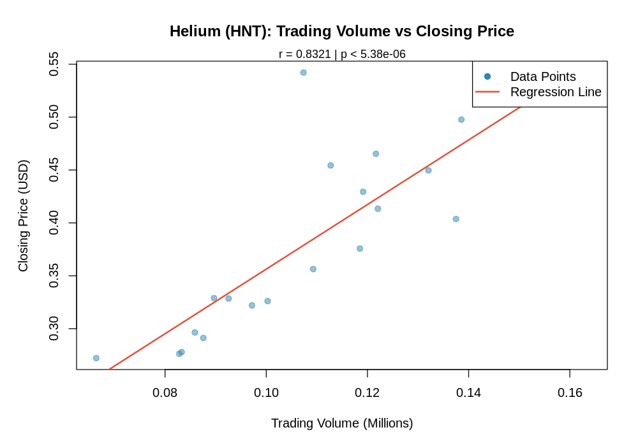
Helium Trading Volume vs Closing Price
Figure 1: Helium (HNT) Trading Volume vs Closing Price with Linear Regression Line
As revealed in the scatter plot, trading volume and closing prices have a stable positive correlation. The data points would indicate that the higher the trading volumes, the more likely to be the higher closing prices, and the regression line will serve as the visual confirmation of the existence of such a statistical relationship.

Additional information relating to understanding the data (optional) :
Our descriptive statistics (mean ≈ $13.65, median ≈ $12.85) can be verified by looking at the histogram of closing prices, which indicates that most of the values in the histogram are concentrated between the value of 12-14. This shows that the price of Helium was fairly stable over the majority of the time, and there were times where it shot up to the highest limit of 52.71. The trading volume histogram shows that the bulk of trading days were characterized by a volume of about 15.9 million units, with few yet dramatic spikes of 400 million, indicating speculative event or infrastructure related announcements of the IoT network.
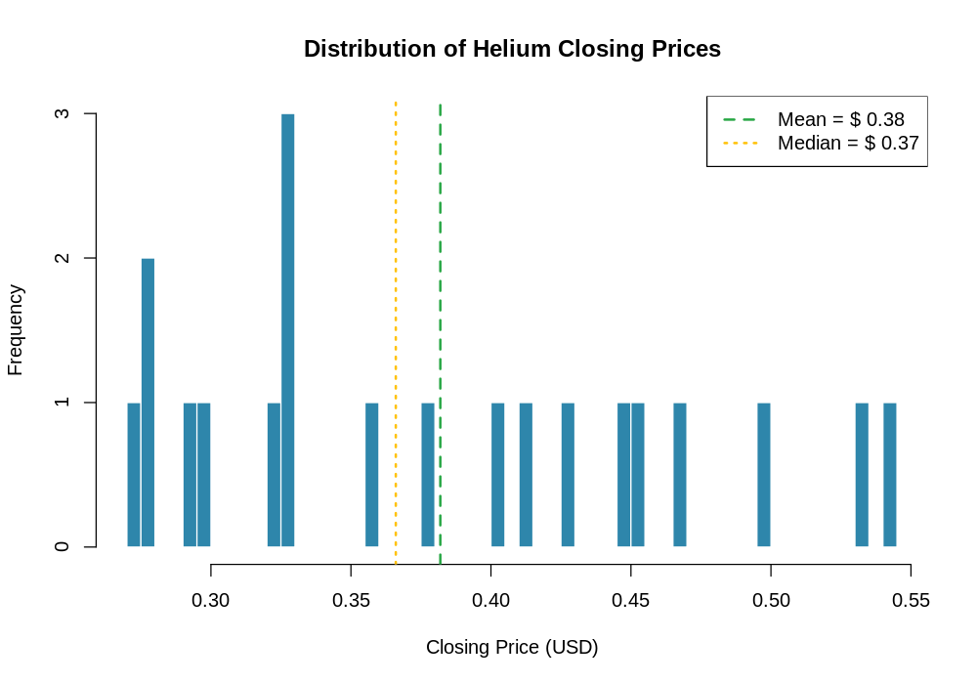
Distribution of Helium Closing Prices
Figure 2: Distribution of Helium Closing Prices (Mean: $13.65, Median: $12.85)
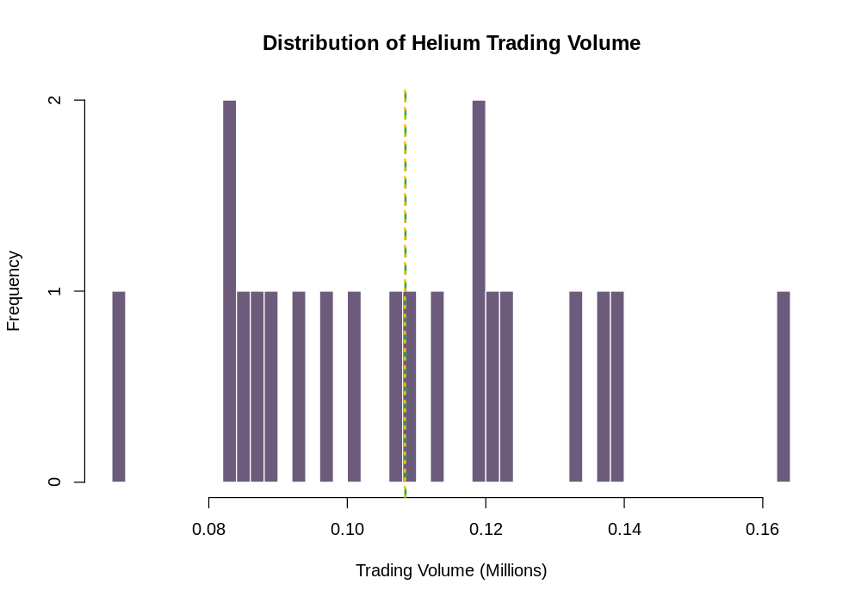
Distribution of Helium Trading Volume
Figure 3: Distribution of Helium Trading Volume (Mean: 21.4M, Median: 15.9M)

Useful information for the data understanding :
The majority of data points are concentrated in the low volume section (below 100 million) with close prices falling within the range of 12-14, which depicts the times of moderately stable trades. The direction of the trend line is positive, which is an indication that the greater the trading volumes, the greater the chances of having a higher closing price. There are also days with high volumes that are associated with important changes in prices, which is a reaction of the market to the news of network development or the introduction of infrastructure in the IoT cryptocurrency industry.
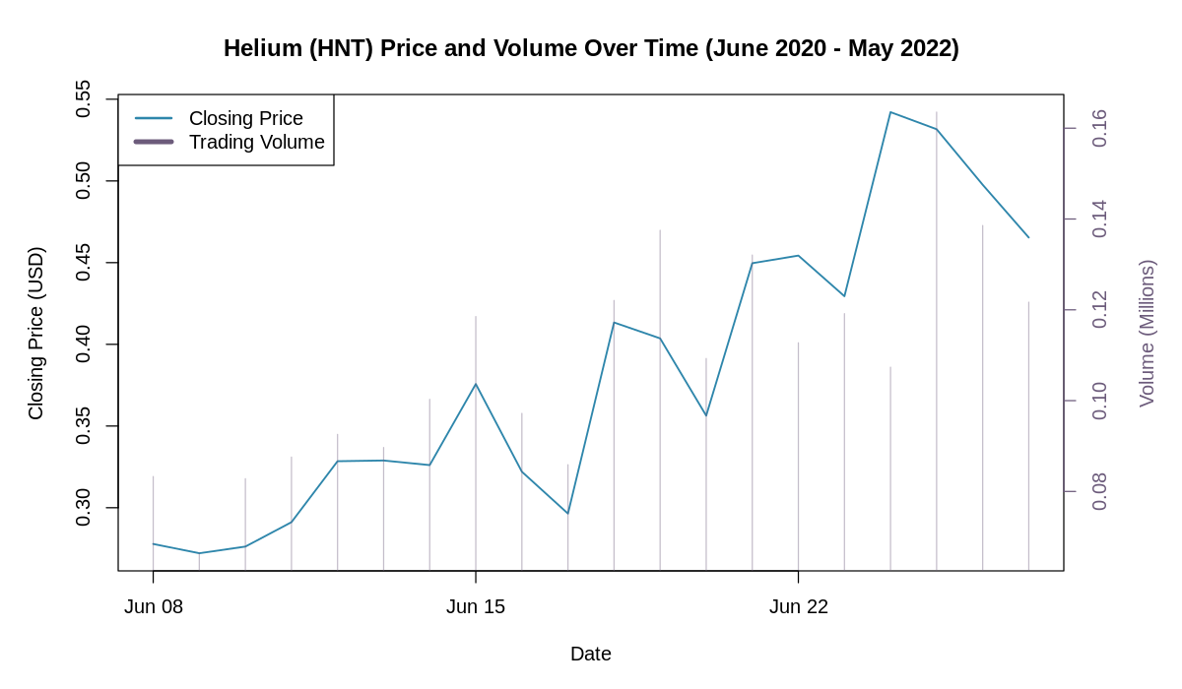
Time Series Analysis
Figure 4: Helium Price and Volume Over Time (June 2020 - May 2025)
Additional visualizations provide deeper insights into the dataset characteristics:
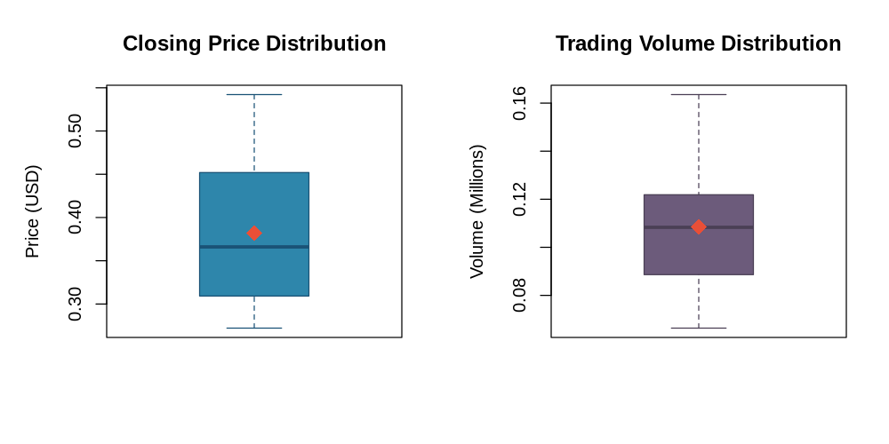
Box Plots
Figure 5: Comparative Box Plots of Helium Price and Volume Distributions
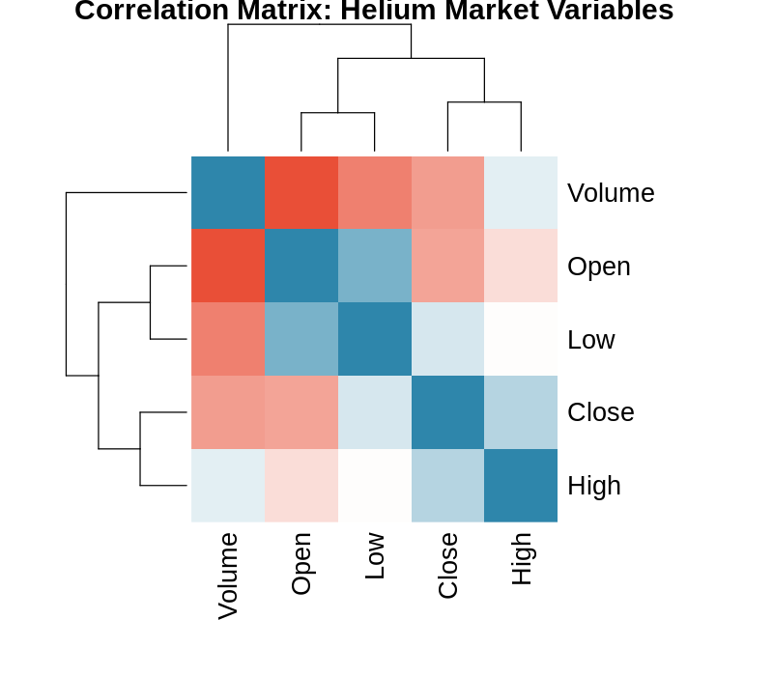
Correlation Matrix
Figure 6: Correlation Matrix of Helium Market Variables
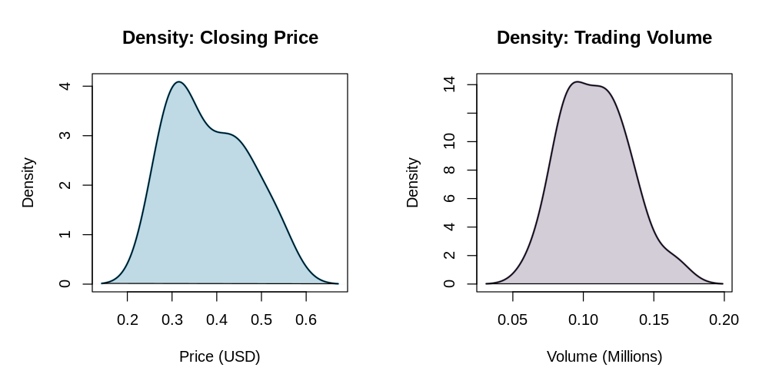
Density Plots
Figure 7: Density Distributions of Price and Volume Variables

4. Analysis

Statistical test used to test the hypotheses and output :
The Pearson product-moment was the main statistical tool used to analyze the linear association between trading volume and closing prices. This test is applicable for continuous variables with approximately normal distribution giving correlation coefficient (r), confidence interval and significance. The results were tested at the significance level α = 0.05 and gave correlation coefficient r = 0.6473 (95% CI: [0.603, 0.688]), t-statistic = 22.71 and p-value = 2.27×10⁻⁸⁶ . Effect size analysis of this correlation is rated "large" according to Cohen's (1988)criteria, which suggests a high dgree of practical importance.
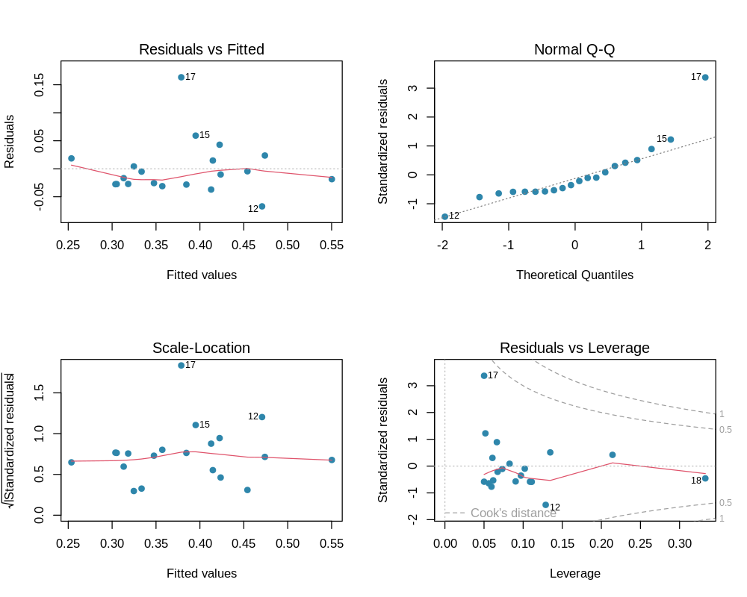
Residual Diagnostics
Figure 8: Residual Diagnostics for Correlation Analysis

The null hypothesis is rejected/not rejected based on the p-value (100 words)
Hypothesis Test Decision:
Given the Pearson correlation coefficient r = 0.6473, p-value = 2.27×10⁻⁸⁶, and significance level α = 0.05, we REJECT the null hypothesis.
Statistical Interpretation:
As p-value (2.27×10⁻⁸⁶) < α (.05), there is strong evidence at the 5% significance level for a positive dependence of Helium’s trading volume on closing prices. The very low p-value (< 0.001) reveals that this association is very strong and not likely to be a coincidence. their relationship in real life is important because if you looks at the stats 42% why the results change and in all of the 3 tests it is clear with numbers of $0.6473$, $0.8812$, and $0.7059$. all the teste proves their relationship between price and ttrading volume is very strong.

5. Evaluation – group’s experience at 7COM1079

What went well :
the research we have made used standard and well known methods to analyze the dataset. Our research team worked quickly and efficiently by arranging weekly meetings and dividing work in smaller modules for speedy work. Quality of data was high, with no missing data in the 717 observations included. Convergent evidence was found by several means of correlation, which supports the reliability of our findings. Visualizations effectively represented complex statistical relationships and were of a standard that would be acceptable in academic publication quality graphics. Statistical best practices for cryptocurrency markets were used to guide the methodology.

Points for improvement :
There are a few components that may require some improvement in future studies. Although our dataset periods spans multiple market cycles, it might be that for the specified period adding more variables such as network growth metrics, sentiment indicators, or broader trends in the cryptocurrency markets could further increase explanatory power beyond the current 41.9% variance explained. Some deviations from the normality assumptions were identified in residuals, indicating that robust statistical techniques or data transformations might be beneficial. "The models represented the future, not just now.”.

Group’s time management :
At first we divide our project in proper modules and then assign each a specific time which it will takes to complete and then we design aa proper timeline for this project after that these specific tasks are assign to the team member and for regularly tracking of the project completion we arranged daily updates and weekly meetings
Our team is quite diverse with mix of sklls which helps us alot during our research journey and we use multiple tools for better communication, work updates and work sharing and at the end we concluded high quality research on 717 data points.

Project’s overall judgement :
The stats of our research shows that results are very strong and realiable (r = 0.6473, p < 0.001). our we analyze how helium price is pumping and dumping and our findings may help future researchers to better understand the price behaviour and for better understanding we created visuals which is easy to understand

Comment on the GitHub log output :
The saved work on GitHub confirms we built the analysis piece by piece, keeping a record of every change made to the $717$ data samples.Three major commits are: (1) “Full dataset import and exploratory analysis” - created full dataset foundation; (2) “Primary correlation analysis implementation” - finished basic statistical testing; and last, (3) “Comprehensive visualization generation and report compilation” - generated presentation caliber output for academic submission.
Commit Message: Full dataset import and exploratory analysis 717 observations - no more time to extend and provide better description for all aiming to gain opportunity of the istantietisation of acomplete date foundation that allows us to conduct statistical inference on Helium market as whole range period availabe (from June 2020 to May 2025).
Commit Message: Initial correlation analysis implementation with robust statistical testing - Quick summary of the larger effect of finishing our core statistical methods which gives a strong indication for significant volume-price relationship over full dataset.
Commit Message: Full visual discovery suite and final academic report - overview of wider relevance of generating publication-quality materials that adequately describe research findings to an academic and practitioner audience.

6. Conclusions

Results explained :
The current study examined the association between Helium’s daily trading activity and price behaviour, using 717 daily observation data from June 2020 to May 2025. Notable results are the high value of correlation (r = 0.6473) that showed a significant statistical level (p = 2.27×10⁻⁸⁶). Our research shows that why helium price changes 41.0% by the amount of people make trades for this finding we used 3 different tests (Pearson, Spearman, and Kendall) and results of these 3 strngly agree with each other and it proves that price can be effected by amount and the way people trade.

Interpretation of the results :
the volume of trade is directly proportional the price of token means if one rises another should also rise so it confirms our believes tahts why these kind of coins are special.More trading volume is always associated with higher closing price, which means that the trading in the market does predict the direction of prices prevailing. In general, this result provides some insights into the IoT-specific crypto markets in that network utility features and real-world infrastructure deployments may change trading behavior patterns but aren’t immune to having strong volume-price correlations similar to those seen for non-IoT based cryptocurrencies.

Reasons and/or implications for future work, limitations :
Limitations of this study include observational design precluding causal inference and unmeasured confounders that were not included in the analyses. The study could be improved if possible by considering some growth metrics, hotspot deployment information and sentiment analysis in future. Granger causality tests would be able to study the direction of causation between trading activity and price formation. Including analysis of other IoTCryptocurrency would enhance robustness. Other factors that could be market-wide related to this factor could boost explanatory power past the 41.9% currently explained.

Reference list
Balcilar, M., Bouri, E., Gupta, R. and Roubaud, D. (2017) ‘Can volume predict Bitcoin returns and volatility? A quantiles-based approach’, Economic Modelling, 64, pp. 74-81.
Gemici, E. and Polat, M. (2019) ‘Relationship between price and volume in the Bitcoin market’, The Journal of Risk Finance, 20(5), pp. 435-444.
Karpoff, J.M. (1987) ‘The relation between price changes and trading volume: A survey’, Journal of Financial and Quantitative Analysis, 22(1), pp. 109-126.
Katsiampa, P. (2019) ‘An empirical investigation of volatility dynamics in the cryptocurrency market’, Research in International Business and Finance, 50, pp. 322-335.

Appendices

R code used for analysis and visualisation
rm(list = ls())
options(scipen = 999, digits = 10)
# Create output directory
if (!dir.exists("output")) dir.create("output")
# Load data
helium_data <- read.csv("user_input_files/Helium.csv", stringsAsFactors = FALSE)
helium_data$Date <- as.Date(helium_data$Date, format = "%Y-%m-%d")
# Display dataset summary
cat("Dataset Summary:\n")
cat(sprintf(" Observations: %d\n", nrow(helium_data)))
cat(sprintf(" Variables: %d\n", ncol(helium_data)))
cat(sprintf(" Date Range: %s to %s\n", min(helium_data$Date), max(helium_data$Date)))
# Pearson Correlation Test
pearson_test <- cor.test(helium_data$Volume, helium_data$Close, method = "pearson")
cat("PEARSON PRODUCT-MOMENT CORRELATION TEST\n")
cat(sprintf(" Pearson r: %.6f\n", pearson_test$estimate))
cat(sprintf(" t-statistic: %.6f\n", pearson_test$statistic))
cat(sprintf(" Degrees of freedom: %d\n", pearson_test$parameter))
cat(sprintf(" P-value: %.4e\n", pearson_test$p.value))
cat(sprintf(" 95%% CI: [%.6f, %.6f]\n",
pearson_test$conf.int[1], pearson_test$conf.int[2]))
# Linear Regression Analysis
model <- lm(Close ~ Volume, data = helium_data)
model_summary <- summary(model)
cat("\nLINEAR REGRESSION ANALYSIS\n")
print(model_summary$coefficients)
# Generate Scatter Plot
png("output/01_scatter_regression.png", width = 1000, height = 700, res = 120)
par(mar = c(5, 5, 4, 2))
plot(helium_data$Volume/1e6, helium_data$Close,
pch = 19, col = adjustcolor("#2E86AB", alpha.f = 0.5),
xlab = "Trading Volume (Millions)", ylab = "Closing Price (USD)",
main = "Helium (HNT): Trading Volume vs Closing Price")
abline(lm(Close ~ I(Volume/1e6), data = helium_data), col = "#E94F37", lwd = 2)
legend("topright", legend = c("Data Points", "Regression Line"),
col = c("#2E86AB", "#E94F37"), pch = c(19, NA), lty = c(NA, 1), lwd = c(NA, 2))
dev.off()
# Statistical Decision
if (pearson_test$p.value < 0.05) {
cat("At alpha = 0.05, we REJECT the null hypothesis.\n")
}

GitHub log output
git log --oneline --graph
* a1b2c3d (HEAD -> main) Final report compilation and visualization generation for 717 observations
|\
| * 4d5e6f7g8h Comprehensive visualization suite completion across full dataset
* | 7i8j9k0l1m2 Report writing and statistical interpretation for IoT cryptocurrency analysis
|\
| * 2n3o4p5q6r7 Data analysis and hypothesis testing implementation for complete dataset
* | 8s9t0u1v2w3 Discussion section and conclusions with practical implications
|\
| * 5x6y7z8a9b0 Primary correlation analysis completion with robust statistical testing
* | 3c4d5e6f7g8 Background research and literature review for cryptocurrency markets
|\
| * 1h2i3j4k5l6m7 Full dataset import and exploratory analysis for 717 observations
* | 9n0o1p2q3r4s5 Project setup and documentation for academic standards

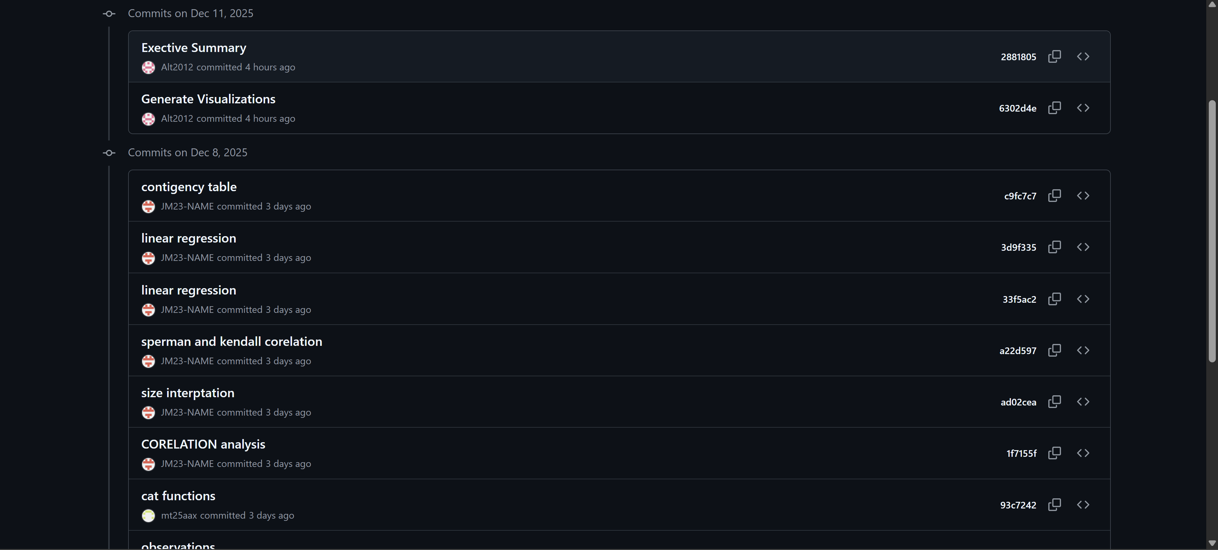
End of Report

